**Wei Liang** **SP17**

**CST 2309-E286**

**Lab#6**

**Prof. Sancar Avcioglu February 27, 2017**

**Lab#6:**

**Source Code for 1-3:**

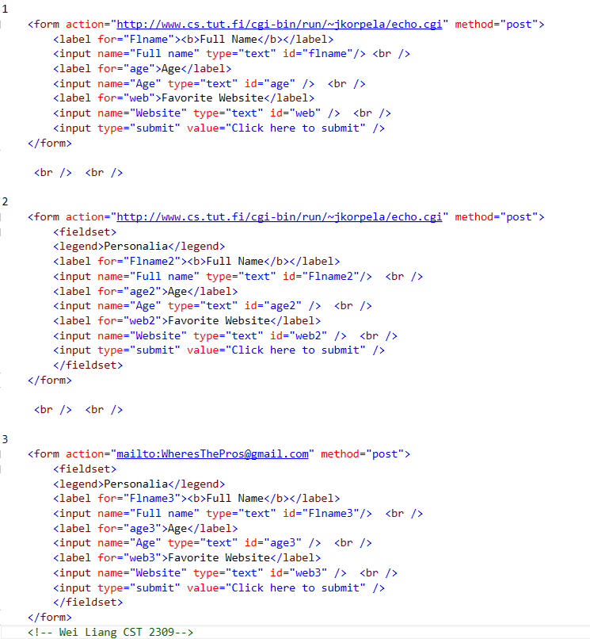

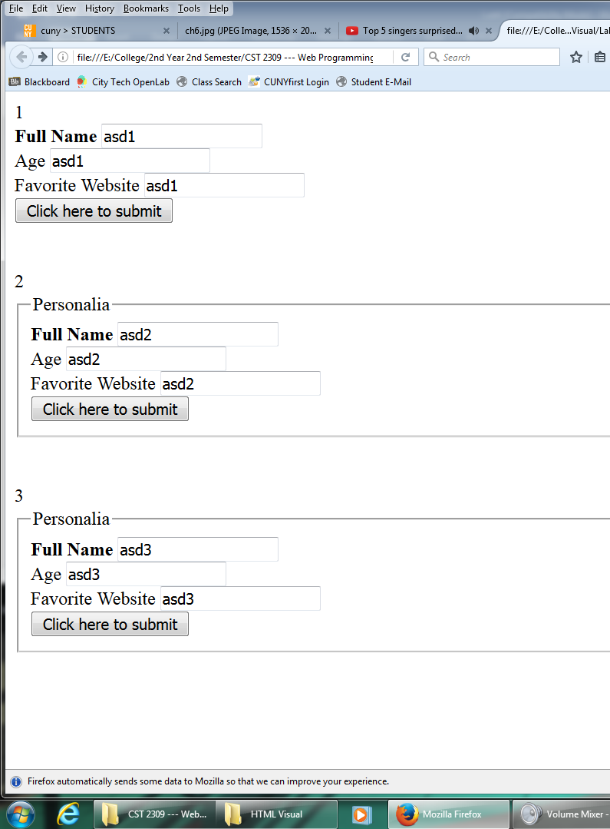

**Q1 Results:**

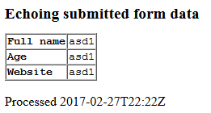

**Q2 Results:**

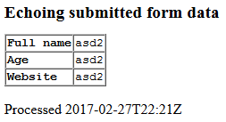

**Q3 Results: [Software not installed in school lab] ☹**

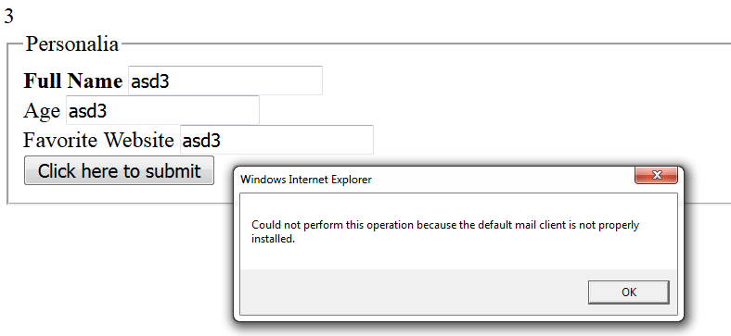

**Source Code for 4-6:**

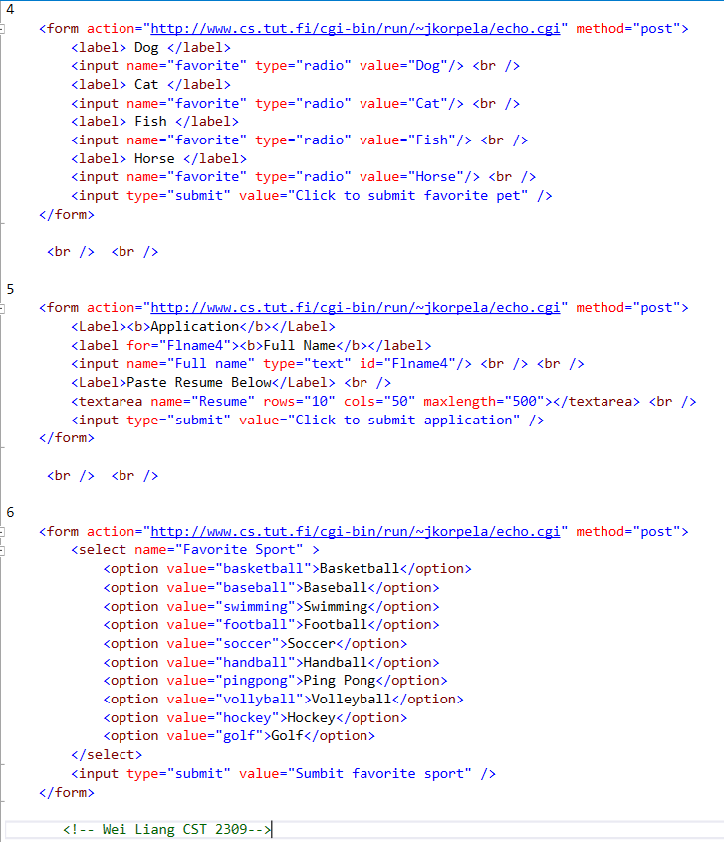

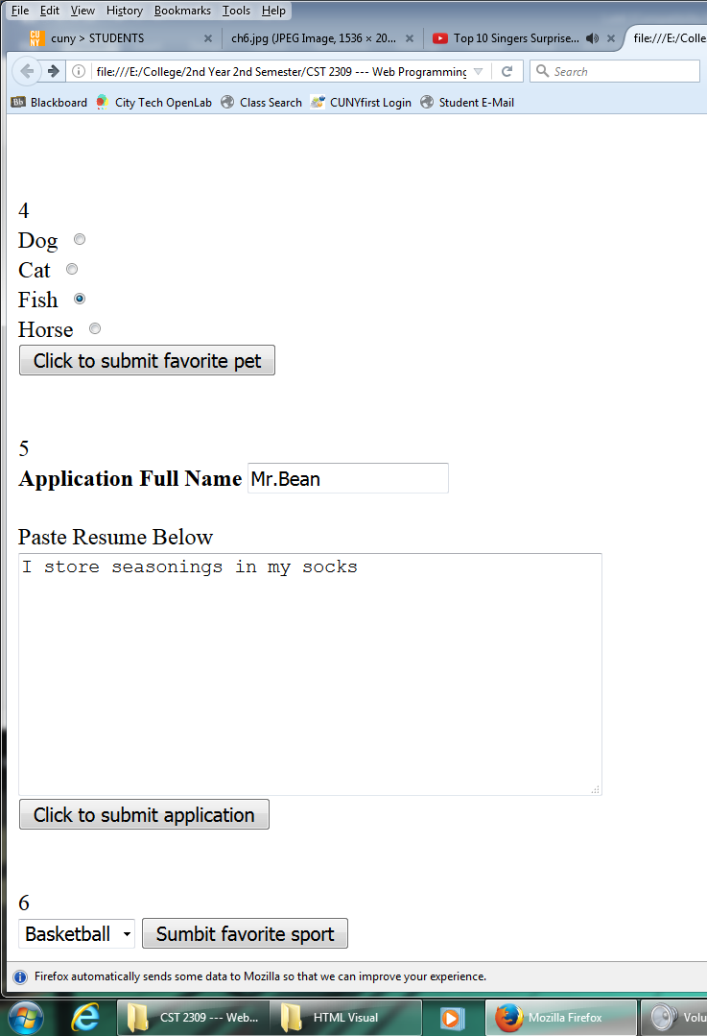

**Q4 Results:**

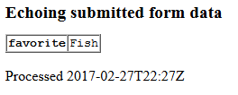

**Q5 Results:**

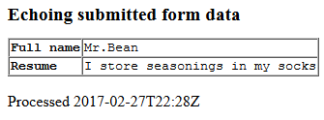

**Q6 Results:**

